Name: ___Li Xianzhe__________ Student ID number: _2022214880

Score: ____________________ / 100

**Laboratory #5 –**

**Thevenin Equivalent Circuits &**

**Maximum Power Transfer**

**EE188L Electrical Engineering I**

**NAU & CQUPT – Fall 2021**

# Objectives

1. Use voltage measurements and calculations to determine the Thevenin equivalent for a given circuit in the laboratory
2. Investigate the relationships between source resistance and load resistance for maximum power transfer.

Grading:

Activity #1 / 20

Activity #2 / 20

# Material

# DC Power source, breadboard, DMM, jumpers

1. Resistors: 6.8kΩ (2), 1.8kΩ, 22k, 10k, 1k, 470 ohms. Also, the calculated resistor RTh

# 

# Important Concepts

1. **Thevenin Equivalent Circuit** – Any linear circuit connected to two terminals can be replaced by an equivalent circuit consisting of a voltage source (VTh) in series with a resistor (RTh) that connect to the two terminals in place of the original circuit. All voltages and currents that can be measured at the two terminals are the same for the original circuit and for the replacement equivalent circuit.

+

_

R

TH

V

TH

a

b

I

N

R

N

a

b

1. **Norton Equivalent Circuit** – Any linear circuit connected to two terminals can be replaced by an equivalent circuit consisting of a current source in parallel with a resistor.
2. **Maximum Power Transfer** – When a linear circuit with a given RTH or RN is delivering power to a load resistor, the power delivered to the load is maximum when the load resistance equals the Thevenin equivalent resistance (RTH) or the Norton equivalent resistance (RN) of the linear circuit.

# Background

**Source Transformation** – A Thevenin Equivalent circuit can be replaced by a Norton Equivalent circuit and vice versa.

I

N

R

N

a

b

+

_

R

TH

V

TH

b

a

I

N

=

V

TH

/

R

TH

V

TH

(I

=

N

)(

R

N

)

R

TH

=

R

N

**Thevenin Equivalent Voltage (V**TH**)** – In all cases this voltage is equal to the voltage at the circuit terminals with no external load connected. This is sometimes called the “open-circuit” voltage.

**Norton Equivalent Current (**IN**)** – In all cases this current is equal to the current that would flow through a wire connected between the circuit terminals. This is sometimes called the “short-circuit” current. This method must not be used to test an actual circuit if the short would burn out the circuit or cause it to operate outside its linear range.

**Thevenin or Norton Equivalent Resistance (R**TH **or RN)** – The methods for determining RTH or RN depend on the type of voltage and current sources contained in the circuit:

1. Circuits with **Independent Sources** ONLY (no dependent sources) – There are three methods:
   1. By Source Removal – First set all sources to a zero value; this is equivalent to replacing all voltage sources with a wire (a “short”) and removing all current sources (leaving an “open” circuit). Second, determine the equivalent resistance of the remaining circuit by “looking into” the terminals; the equivalent resistance is the value of RTH or RN.
   2. By Short-Circuit Current – This method applies during analysis of a circuit or in testing an actual circuit that can safely have a short circuit at its terminals. First, determine the voltage at the terminals with no load connected; this is VTH. Second, determine what current would flow through a wire connected between the terminals; this is the short-circuit current (Isc). RTH can then be

|  |  |
| --- | --- |
| calculated: |  |
| RTH = VTH / Isc | RN = RTH |

* 1. By Applying a Load – This method applies when testing an actual circuit to find its equivalent source resistance (RTH or RN). First, measure the voltage at the terminals with no load connected; this is VTH. Second, connect a load resistor to the circuit terminals; the load resistor (RL) should be low enough to cause a measurable voltage drop from no-load conditions, but not so low as to cause the circuit to malfunction or operate outside of its linear range. RTH can then be calculated:

RTH = (VTH – VL) ∙ (RL) / (VL) RN = RTH

## Maximum Power Transfer

Given an existing circuit with a Thevenin resistance (RTH), the maximum power is transferred to the load resistor (RL) when the value of the load resistor is selected to match the value of the Thevenin resistance (RTH) of the power source. Figure 1 demonstrates this for a value of RTH = 10 Ω.

|  |  |
| --- | --- |
| **Load Power Response to Changes in RL**  **for Rth = 10 ohms**                    0    0.5    1    1.5    2    2.5    3    0    10    20    30    40    50    **Power (watts)**    **R**  **L**    **ohms**  **)**  **(** | RTH = 10    +    _    10 |
| P = I2 ∙R  = V2 /R |
| Figure 1 |

# Activity #1 – Thevenin Equivalent of the given circuit

In this activity, you will determine the Thevenin equivalent circuit values (VTH and RTH) for the circuit below on your lab bench by performing measurements and some calculations using method 1a and 1b, as explained earlier.

1. Get the 3 resistors shown in the circuit and connect them on the breadboard as shown in the circuit diagram below.
2. Do NOT yet connect the dc power supply! Place a short-circuit (wire) across what will be the source voltage terminals, and **measure the Rin** with your DMM, looking into the circuit from the load side. **This measured resistance is RTH**Remove the short after the resistance measurement!

**RTH** = _____5.165kΩ________________

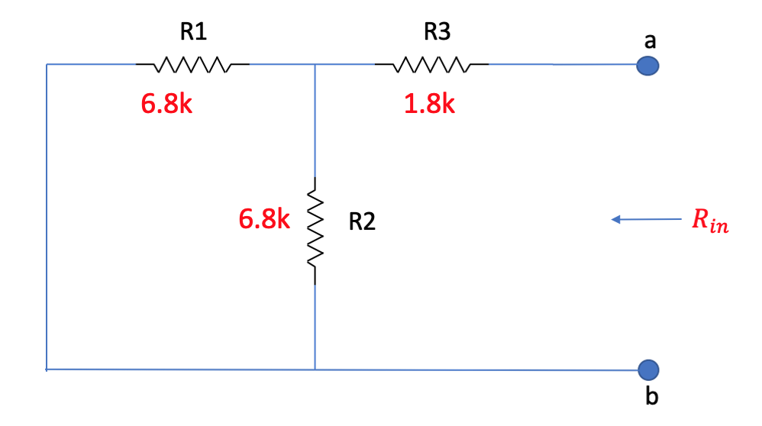

1. Now, adjust the dc power source to read 20 volts on one of the output channels and connect it to the circuit, as shown below. There should be no load resistor connected to the output (terminals a & b) yet.
2. Accurately measure and record the (open-circuit, **without** RL connected) output voltage Voc at terminals a & b.

Voc with no load = VTH = ____10.085V_________________

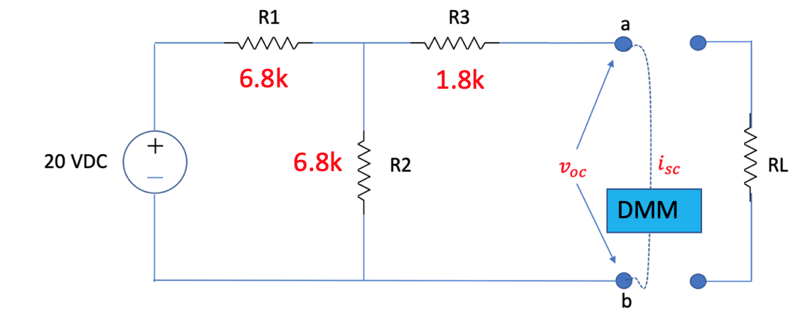

1. Next, **still without RL connected**, measure the short-circuit current (Isc) between terminals a & b. To do this, set the DMM to measure Milliamps and connect it across terminals a & b. **This ensures that the DMM is in series within the short-circuit.**

Again, **RTH = VTH / Isc**. Check that this value is the same as from Step 2 above.

**RTH** = VTH / Isc =10.085/(1.977*10^-3)=5.101KΩ

1. Draw the Thevenin equivalent circuit for the function generator output showing values for VTH and RTH based on your measurements and calculations.

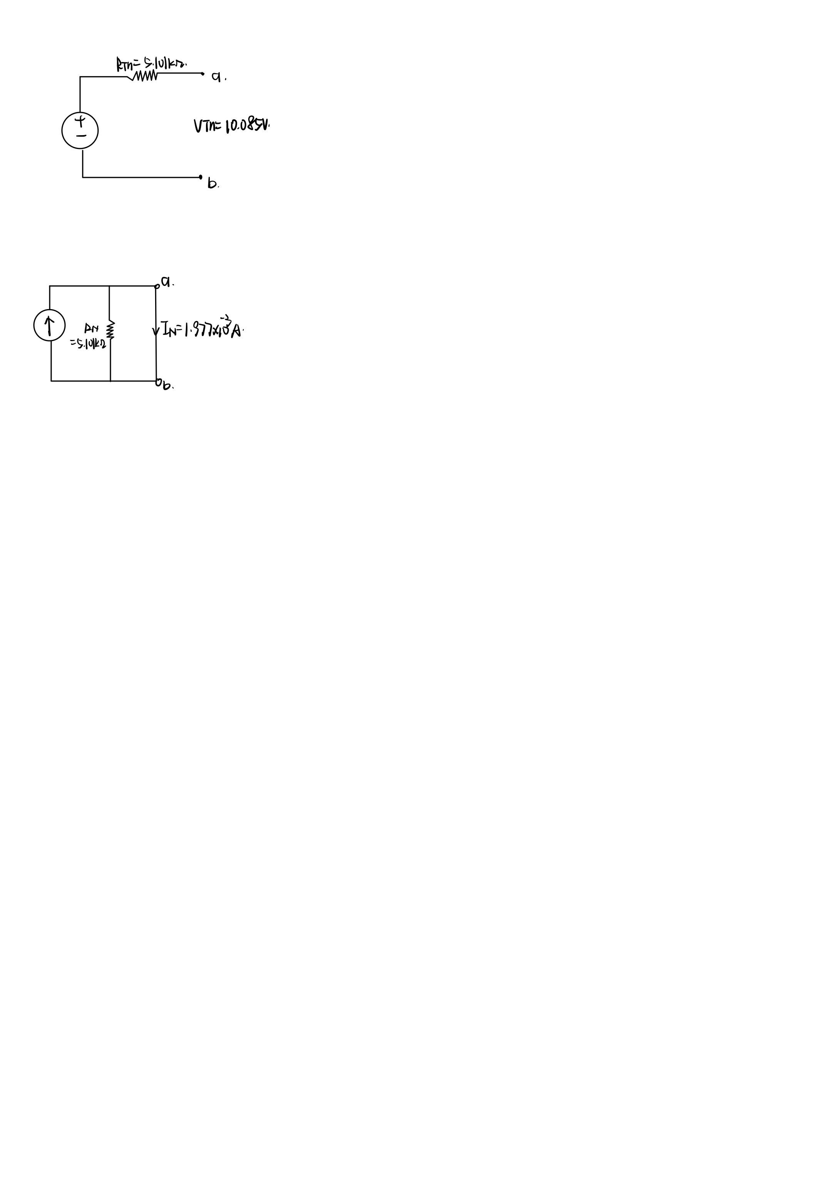

1. Using your values for VTH and RTH, calculate the Norton equivalent circuit values IN and RN. Draw the Norton equivalent circuit for the function generator output showing values for IN and RN.

# Activity #2 – Maximum Power Transfer

1. With the same circuit setup used in Activity #1, now connect the load resistance between terminals a & b. Measure and record the output voltage (at terminals a & b) with **Use different load resistors to act as the load (RL).** The resistance values to use are as shown in the table below.

**One of the resistors to use should equal the RTH in value!**

|  |  |  |
| --- | --- | --- |
| Load Resistance (Ω) | Output Voltage (VL) | Calculated Power to the Load (watts) |
| 470 ohms | 0.825V | 1.44*10-3W |
| 1.0k | 1.619V | 2.62*10-3W |
| RTH | 4.992V | 4.88*10-3W |
| 10k | 6.604V | 4.36*10-3W |
| 22k | 8.123V | 3.00*10-3W |

1. Calculate the power delivered to the load for each of the test conditions and enter it in Table 1. (The equation for PL is /R.)
2. Plot the various values of power in the table, similar to Figure 1. Discuss how your measurement results compare with the concept of Maximum Power Transfer:

Discussion:

When RL=RTH, the power is greater than other RL values, and the measurement results are basically consistent with the concept of maximum power delivery. In other words, when the resistance of the load is equal to the equivalent resistance of the original circuit, the power is maximized.

**Have your lab instructor or lab aide sign below after they have checked your progress.**

Signature _____________________________________ Date ________________



